AM Radio

Design Report

David Harris
300069566

PHYS341- 2005
Victoria University of Wellington
Summary

The design task was to build an AM radio out of discrete components. This task was divided into five sections. In order, these are the emitter follower, common base, rectifier circuit, OP amp circuit and power amplifier. The emitter follower acts as a current buffer with it's high input and low output impedance. This is then connected to a pair of common base amplifiers, giving a total voltage gain of approximately 1000. This is then connected to a rectifier which separates the carrier and the data signals. The sound waves are then passed through a op amp, which amplifies the signal so it able to be heard. The final stage of the circuit is a power amp that gives enough power to drive the speaker.

I have tested each section of the circuit individually when constructing the radio, making sure that each works the way it should. However, when putting the circuit together as a whole, no sound is heard. This could be a wide range of things, which I detail in the Problems section.
Introduction

The radio was built in five sections, each performing one task to enable to whole system to function. The demodulator, or 'tuning circuit' was given to us as plug-in. This consisted of an inductor and a variable resistor that actually tuned in to the radio frequencies. The antenna was attached to this. This then connected to the emitter follower (or common collector). This boosts the current of the input signal, while giving no voltage gain. This sets the impedance of the circuit, as the impedances between the components must match, otherwise each section forms a voltage divider. Therefore, the output impedance of the emitter follower must be the same as the input impedance of the common base amplifier. The common base amplifier has a voltage gain of about 1000. To do keep the circuit stable, this has been done in two separate amplifiers with a gain of 500 each. Having a gain of 1000 made some ringing in the circuit, and some complex negative feedback would have been needed to combat it. Now with both the current and voltage increased, the signal was passed through a rectifier circuit. This separated the actual data signal, from the carrier signal. This consisted of a capacitor and resistor in series. The values of these were chosen so as to make the time constant between the period of the AM radio signal and the spoken voice. The data signal is then amplified by an op amp with a gain of about 10. This gives the signal enough amplification so it can be hard out of the speaker. The last stage is a Power amp, which increases the current, so the speakers can be driven.
Description of Design Task

The emitter follower (or common collector) was designed so as to have an input impedance of about 100kΩ and an output impedance of less than 1kΩ and a bandwidth of 500kHz to 1.6MHz. The advantage of an emitter follower is that it has a low output resistance and high input resistance, which means that it has a large current gain. It is the first amplification stage because once the current is increased, the voltage can next be increased in the next stage, to give a larger input signal. For the details of how the emitter follower was biased, see the appendices. The next stage was the common base, which acted as an RF amplifier. As the current was not at a suitable, the voltage could not be amplified. The desired gain was about 1000, without the transistor going into saturation. The main characteristics of the common base are a very low input resistance, relatively high input resistance and a large gain. The circuit diagram of the emitter follower and common base are shown below.

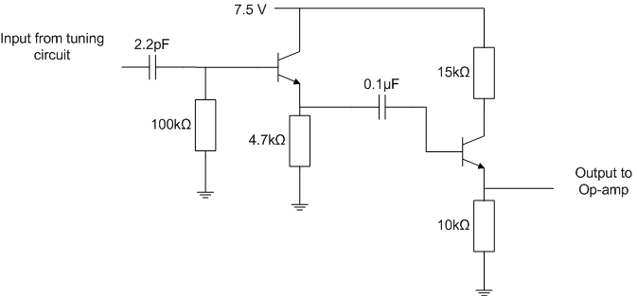
Illustration 1: Emitter Follower and Common Base configuration
The signal then went through a rectifier that would and a high-pass filter. The rectifier blocked the negative part of the incoming sinusoidal wave, and the high-pass filter separated the signal from the carrier wave, and allowed the signal to pass through. The values of the resistor and capacitor had to be chosen carefully to ensure they allowed the AM band (500kHz to 1.6MHz) was not passed through, but the voice (20Hz to 20kHz) was. The components formed a RC circuit with a time constant τ = RC.
Problems and Improvements
Performance
Cost Estimate
Appendices

